Vegetation dynamics following low-intensity ground fire disturbance in a rare ecosystem subtype - grassy balds - and management implications for conservation of Round Bald

Master’s student thesis proposal for Western Carolina Universtiy

J. Ted Hillert

**Disclaimer** *This is not a full literature review. I still have >12 sources to read and annotate and whatnot. However, it’s been too long (I’ve been slacking) and I NEEDED to put something down (I’m ignoring the fact that its ~~crap~~ verbose, conciseness can come later). Secondly, I wanted to make sure I got something in before the start of the semester, in order to get it review’d and edited by the middle (hopefully) of January. So long as I keep my ducks in a row, I plan to have a full draft by MARCH.*

# INTRODUCTION

### History, in briefs

Upper montane treeless meadows - balds - host high floral diversity, panoramic views of the landscape, and origins shrouded in mystery (Murdock 1968, Gersmehl 1970, Hamel and Somers 1990). There has been much in the way of “bald history” in the literature, but there is relatively little regarding vegetation dynamics following disturbance. Management of these balds varies by agency, type of bald - heath or grass, and proposed history - whether it was cleared, grazed, burned, or some combination of these (Lindsay and Bratton 1979b, Weigl and Knowles 1995, 2014). Separating bald origins and subtype vegetation dynamics is key to preserving these dwindling ecosystems and to conserve them for future generations to enjoy (Moravek et al. 2013). Here, our intention was to examine changes in the vegetation community following a low-intensity ground fire in February of 2022, that burned approximately 24 acres on Carver’s Gap. Fortunately, there was pre-burn data from a recent study by Stokes and Horton (2022), they had examined the vegetation composition following 30 years of mowing management (Murdock 1968, Hamel and Somers 1990) using the similar methods used here.

### Woody Encroachment

The United States Forest Service (USFS) acquired Southern Appalachian bald lands in the early 1900s *[include approx date]* after which point, active management ceased and nature took its course of these supposedly anthropogenic ecosystem subtypes (Lindsay and Bratton 1979a, 1979b, Lindsay and Bratton 1980). Following management cessation, the range of grass balds along the Southern Appalachian Mountains (SAMs) has decreased by *[find approx %]* since Murdock (1968) surveyed the bald in the 1980s. A repeated survey of the balds of Carver’s Gap in 2020 by Stokes and Horton (2022), revealed a [*find % dec/inc*] in the cover of *Rubus allegheniensis* and *Rubus canadensis* (*Rubus*) two primary invasive species transforming this grassy bald into a heath bald.

### Managment Practices

Management of balds along the Southern Appalachian Mountains varies by agency and suspected origins, with most practices promoting mowing or grazing, with few instances of fire for clearing. When used, fire needs to be of high intensity or high duration to provide a significant effect against woody encroachment (Lindsay and Bratton 1980). Germination requirements of the invasive genus *Rubus* include scarification - some damage to the seed has to occur (Davies 1998) - fire can provide that damage and could possibly alter growth patterns the following season. Sufficiently hot or lengthy burns have the potential to retard the growth of blackberry, however post-burn analysis of the vegetation community indicates that the resulting community is not characteristic of grass balds (Lindsay and Bratton 1980). Likewise, prescribed burns are difficult to manage at such high elevations and soil moisture levels, not to mention the understudied effects on rare and endemic species of true balds.

### Round Bald

Like several balds across the globe, Round bald is experiencing woody encroachment from invasive species like *Rubus allegheniensis*, *Rubus canadensis*, *Vaccinium spp.*, *Rhododendrom spp.* and saplings from the surrounding spruce-fir forest. These species are causing this grass bald into an ericaceous heath bald and potentially extirpating a rare ecosystem subtype that provides panoramic vista views of the adjacent mountaintops. Nearly 40 years ago, Murdock (1968) and Hamel and Somers (1990) examined the vegetation community of Roan Mountain balds when the decision to protect these landscapes started to change. In 2020, following 30 years of mowing management, Stokes and Horton (2022) re-surveyed plots from Murdock (1968) and Hamel and Somers (1990) - providing pre-burn data without realizing. In February of 2022, there was a low-intensity ground fire that burned for less than 6 hours *[according to the news article* ***need to contact NPS for more detail****]* and burned approximately 24 acres of Round Bald. Roughly half of the plots were within the fire and the other half was outside of the fire boundary on Round Bald. In the Summer of 2022 we surveyed a total of 95 plots, in the Summer of 2023 we plan to re-survey these plots and take a second soil seed bank sample.

# OBJECTIVES & EXPECTED RESULTS

The objectives of this study are to; 1. Quantify vegetation dynamics following low-intensity ground fire a. in the soil seed bank AND b. in vegetation composition by percent cover of major functional types. 2. Propose methods to improve management for conservation of these rare ecosystem subtypes while the debate about their origins lingers. The greater question is, how has the low-intensity ground fire affected vegetation dynamics and are there practices that could be gleaned from this disturbance? We expect that there is little to no decrease in the cover of *Rubus spp.*, likely there will be a slight increase in blackberry cover following slight scarification from the ground fire.

# METHODS

## 2022

### Field

Round Bald is located in the Roan Mountain Massif of the Unaka Mountain range of the Southern Appalachian Mountains, between Carver’s gap and Engine gap. The Appalachian Trail (AT) bisects the study site into North of the trail and South of the trail. The site itself is spread across Pisgah National Forest in North Carolina and Cherokee National Forest in Tennessee, at approximately 36° 06’N and 82° 60’W. In this study I sampled transects reestablished by Stokes and Horton (2022) after a 30-year mowing management protocol established by Hamel and Somers (1990) and Murdock (1986). We measured the percent coverage of vegetation using a 1-m2 PVC quad-rat divided into 100 equal sized squares. Each square was visually assigned by dominant vegetation type to equal 100% coverage per plot. Using the data collection tool from Stokes and Horton (2022) and USFS botanist Gary Kauffman, a total of 226 plots along 12 transects were sampled in 2020, of these, 52 plots along the first four transects were in the February 2022 fire and another 47 plots along the same transects were untouched by the fire. This provided an opportunity to examine the changes in plant community composition following low-intensity ground fire over two sampling seasons in June of 2022 and 2023.

### Greenhouse

To examine the effects of the fire on the seed bank, seed bank samples were collected in July 2022. Approximately X grams of soil was obtained from the top 5 cm of soil at six random sites in one of four treatments; over 50% *Rubus*-in fire, over 50% *Rubus*-out fire, under 25% *Rubus*-in fire, under 25% *Rubus*-out fire. A total of 24 soil seed banks samples were taken, placed in tins, transferred to the greenhouse, and placed in 11x8.5 inch seedling trays filled with potting mix to 5 cm depth. An additional six trays only filled with potting mix will act as greenhouse controls to rule out contamination. Trays were randomly set in the greenhouse at ambient temperature and humidity and measured continuously with a Govee probe. As seedlings emerge they will be identified, recorded, and removed; while the species that cannot be identified will be re-potted until identifiable following Price et al. (2010). Each month the trays were rotated in random order to rule out growth condition bias. In December of 2022, soil sample trays were placed outside to simulate winter conditions and potentially germinate seeds in the seed bank *[Unfortunately, They were placed in a poor position and the weather washed out 1/2 the dirt from 1/3 of the trays, then froze. I have since readjusted them and covered them for safety. Maybe it’s salvageable?]*. A second soil sample following the same protocol will be conducted in March of 2023. These samples will examine what is readily germinable following natural winter weathering and be compared to the first seed bank set to examine post burn germinable *[wrong word?]* seeds versus post winter germinable seeds.

## 2023

### Field

Much of what we do next summer, is repeated from what was done in 2020 and 2022, however we will add a second method to our soil seed bank analysis to provide a more robust estimate of the seed bank and make it more comparable to the current vegetation structure and to speculate on the future composition of Round Bald as a result of mowing management. In 2022 soil emergence was utilized for the sake of time, we plan to add modified soil extraction methods from Price et al. (2010), Abella et al. (2013), and Chiquoine and Abella (2018). These authors identify that both methods can provide insight into the vegetation community, but a combination of the two provides a more robust estimate of the state of the bald.

# PROPOSED BUDGET

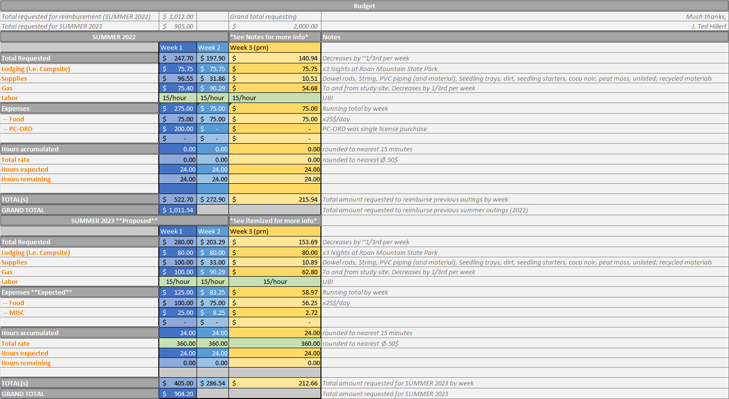

Figure 1: Proposed budget for Summer 2023 research and requested reimbursement for Summer 2022 research.

# References

Abella, S. R., L. P. Chiquoine, and C. H. Vanier. 2013. [Characterizing soil seed banks and relationships to plant communities](https://doi.org/10.1007/s11258-013-0200-3). Plant Ecology 214:703–715.

Chiquoine, L. P., and S. R. Abella. 2018. [Soil seed bank assay methods influence interpretation of non-native plant management](https://doi.org/10.1111/avsc.12393). Applied Vegetation Science 21:626–635.

Davies, R. 1998. Regeneration of blackberry-infested native vegetation. Plant Protection Quarterly 13:189–195.

Gersmehl, P. 1970. A geographic approach to a vegetation problem: The case of the southern appalachian grass balds. Ph.D. Dissertation, University of Georgia, Athens, GA. 463 pp.

Hamel, P., and P. Somers. 1990. Vegetation analysis report: Roan mountain grassy balds. Challenge Cost Share Project.:25.

Lindsay, M. M., and S. P. Bratton. 1979a. [The vegetation of grassy balds and other high elevation disturbed areas in the great smoky mountains national park](https://doi.org/10.2307/2560352). Bulletin of the Torrey Botanical Club 106:264–275.

Lindsay, M. M., and S. P. Bratton. 1979b. [Grassy balds of the great smoky mountains: Their history and flora in relation to potential management](https://doi.org/10.1007/BF01866581). Environmental Management 3:417–430.

Lindsay, M. M., and S. P. Bratton. 1980. The rate of woody plant invasion on two grassy balds. Castanea 45:75–87.

Moravek, S., J. Luly, J. Grindrod, and R. Fairfax. 2013. [The origin of grassy balds in the bunya mountains, southeastern queensland, australia](https://doi.org/10.1177/0959683612460792). The Holocene 23:305–315.

Murdock, N. A. 1968. Evaluation of management techniques on a southern appalachian bald. Unpublished M.S. Thesis. Western Carolina University. 62 pp.

Price, J. N., B. R. Wright, C. L. Gross, and W. R. D. B. Whalley. 2010. [Comparison of seedling emergence and seed extraction techniques for estimating the composition of soil seed banks](https://doi.org/10.1111/j.2041-210X.2010.00011.x). Methods in Ecology and Evolution 1:151–157.

Stokes, C., and J. L. Horton. 2022. [Effects of grassy bald management on plant community composition within the roan mountain massif](https://doi.org/10.2179/0008-7475.87.1.105). Castanea 87:105–120.

Weigl, P. D., and T. W. Knowles. 1995. [Megaherbivores and southern appalachian grass balds](https://doi.org/10.1111/j.1468-2257.1995.tb00176.x). Growth and Change 26:365–382.

Weigl, P. D., and T. W. Knowles. 2014. [Temperate mountain grasslands: A climate-herbivore hypothesis for origins and persistence](https://doi.org/10.1111/brv.12063). Biological Reviews 89:466–476.